POWER BI – HANDS ON ASSESSMENT

* Praket Sanganeria (655221)
* Unext ID – SH7B23162

Requirement 1: Data Loading –

Creating a database and creating tables inside the database

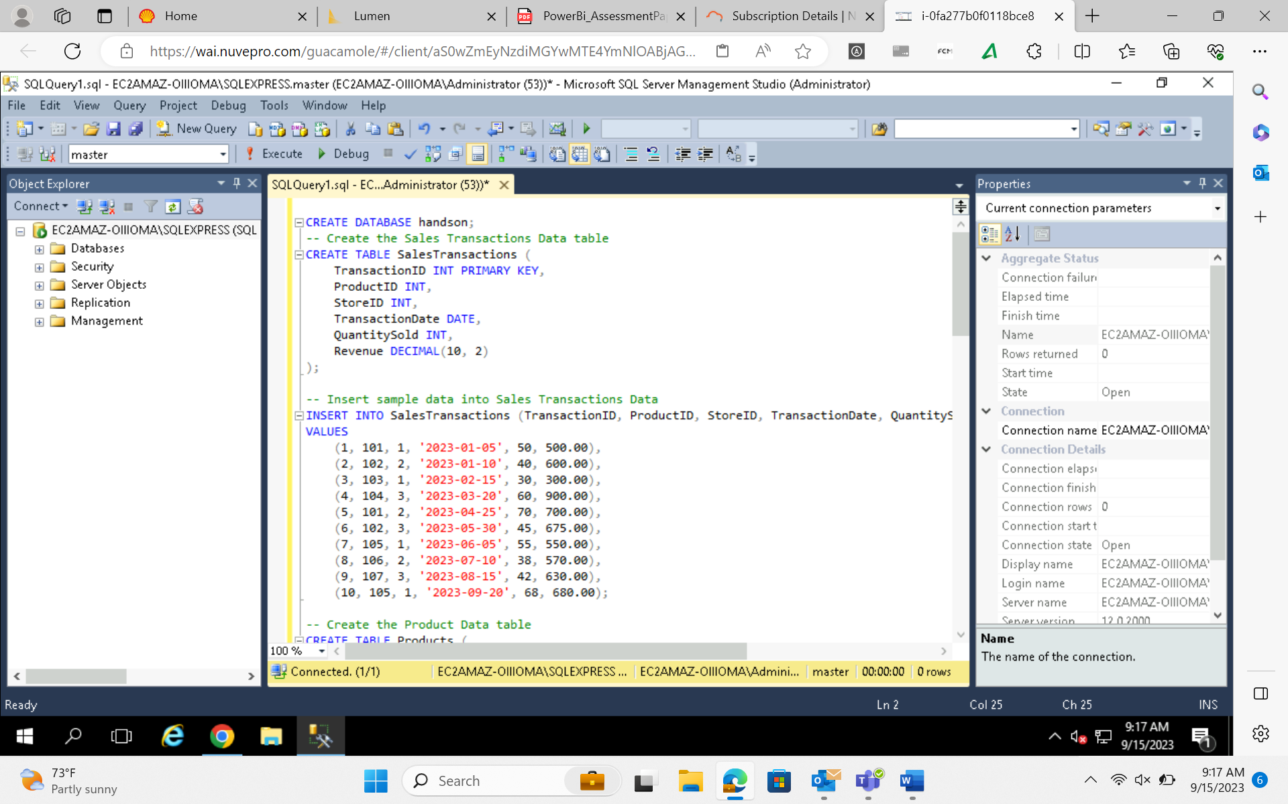

Connecting the database to PowerBI and loading the dataset –

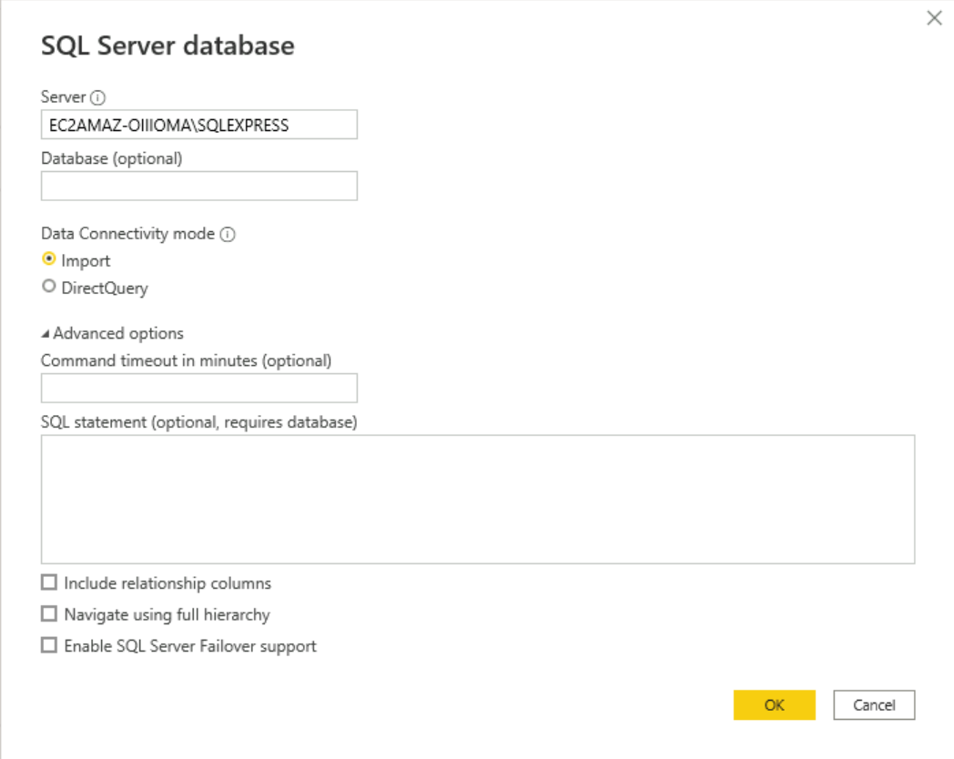

Selecting the tables –

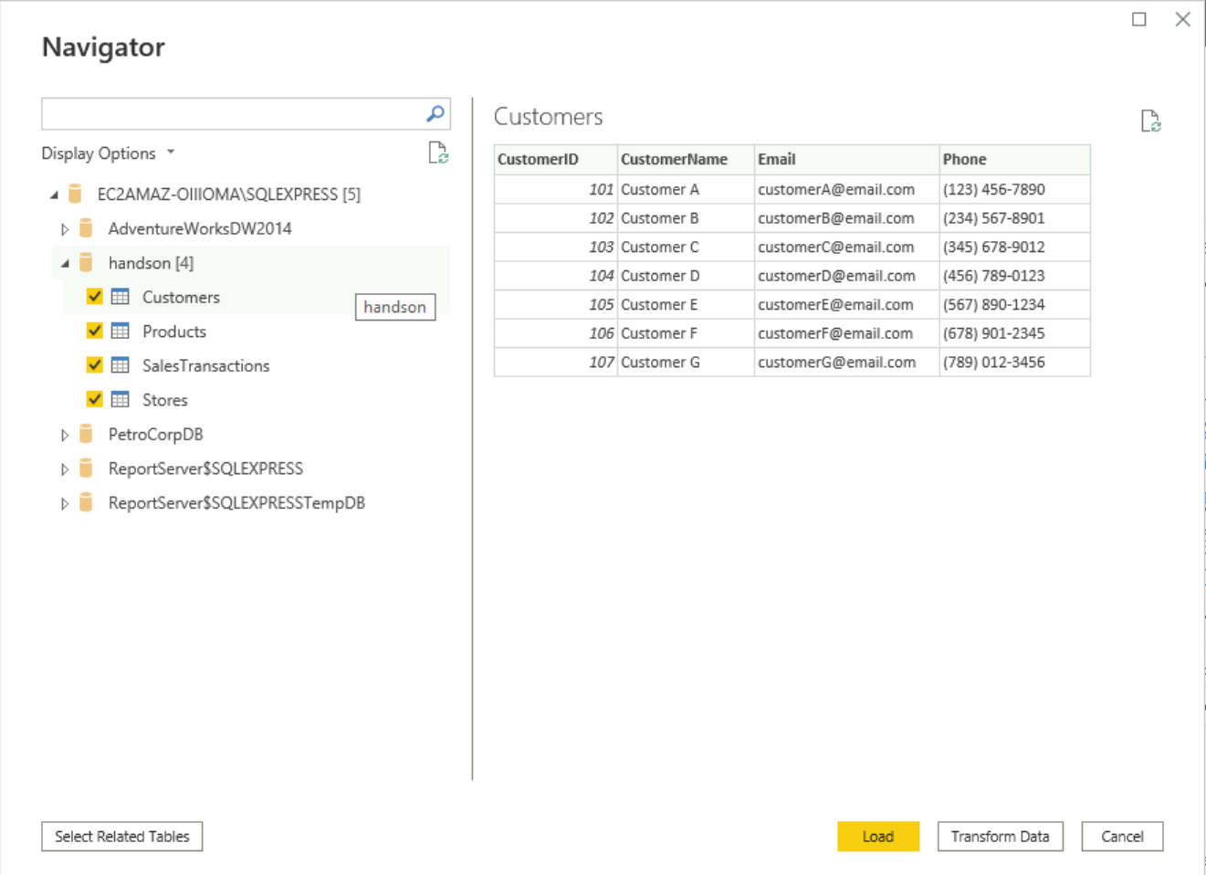

Requirement 2: Data Transforma7on –

• Merge Tables: Merging SalesTransaction and Stores tables

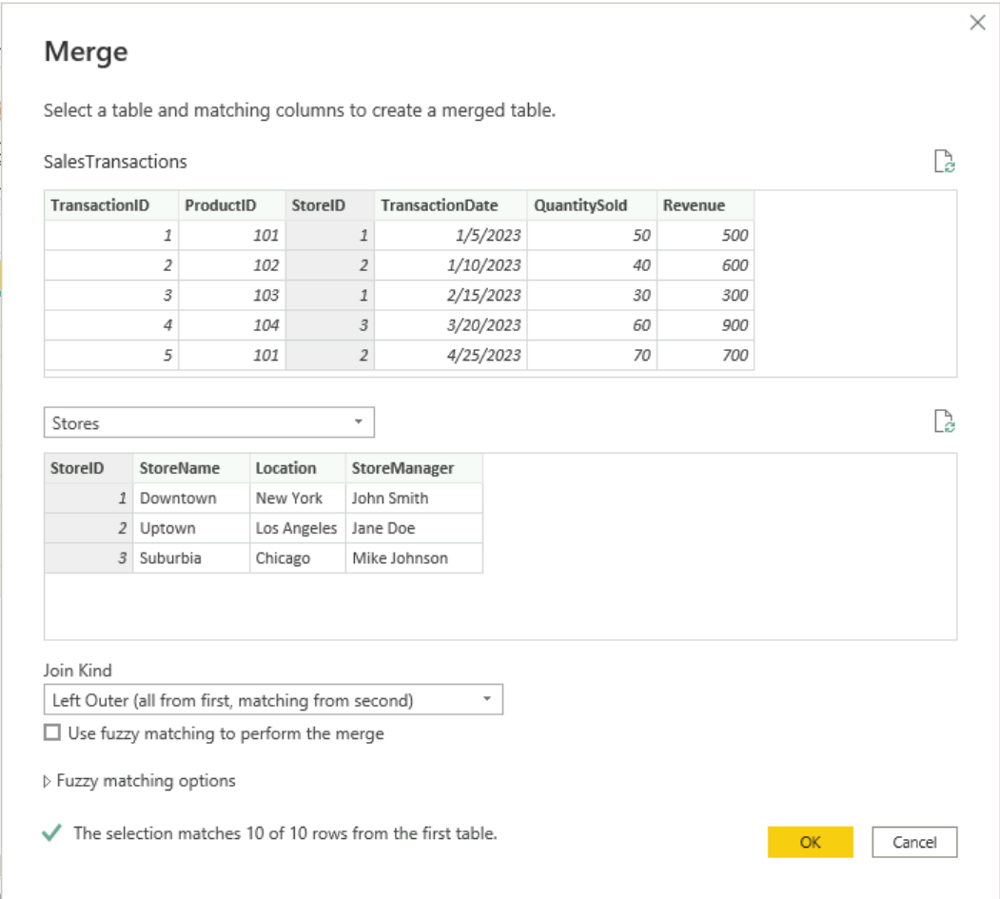

Expanding the merged table -

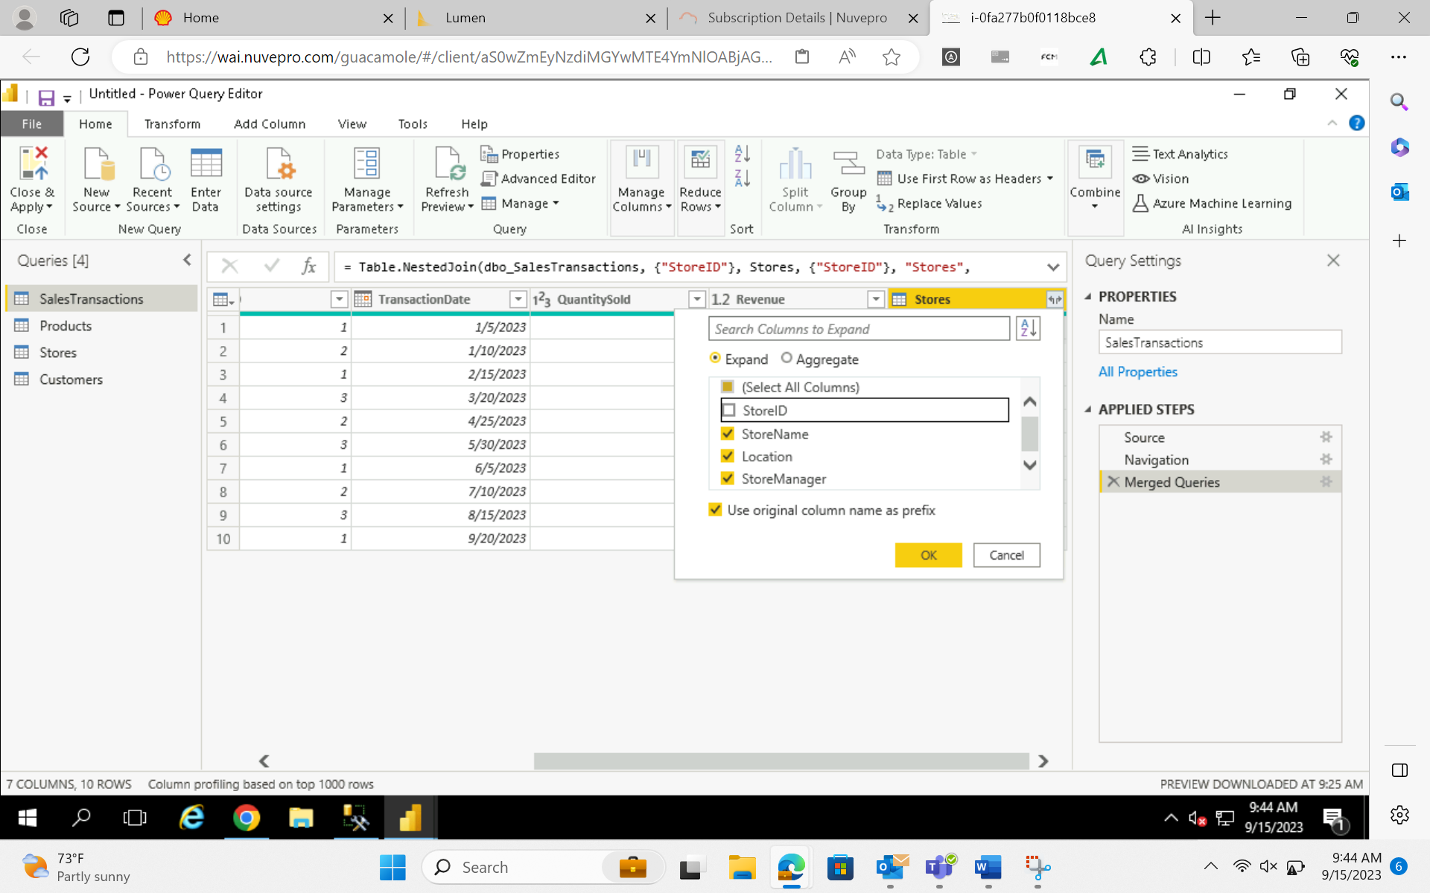

Merging SalesTransaction and Customers table –

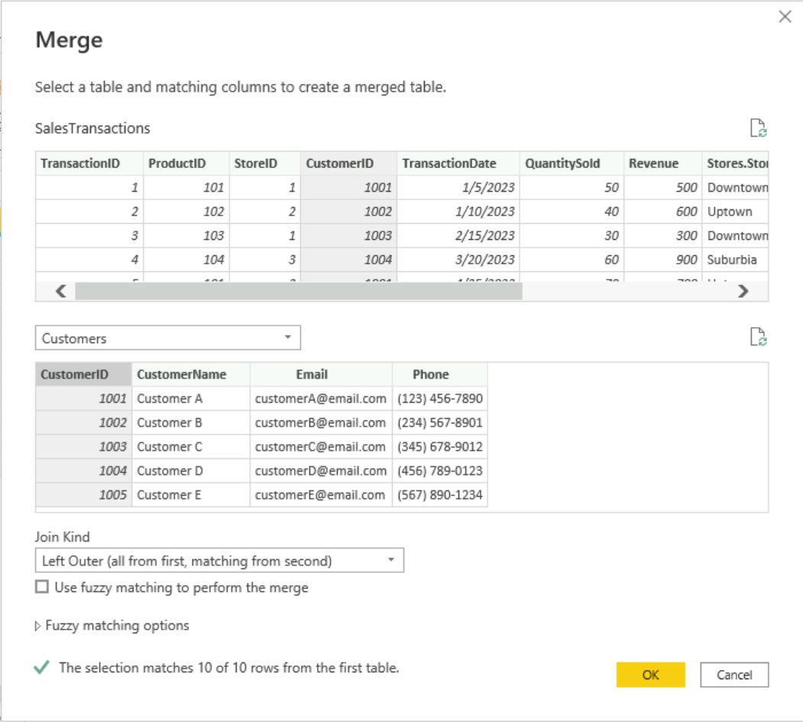

• Create Calculated Columns:

Creating a final_revenue Column using DAX –

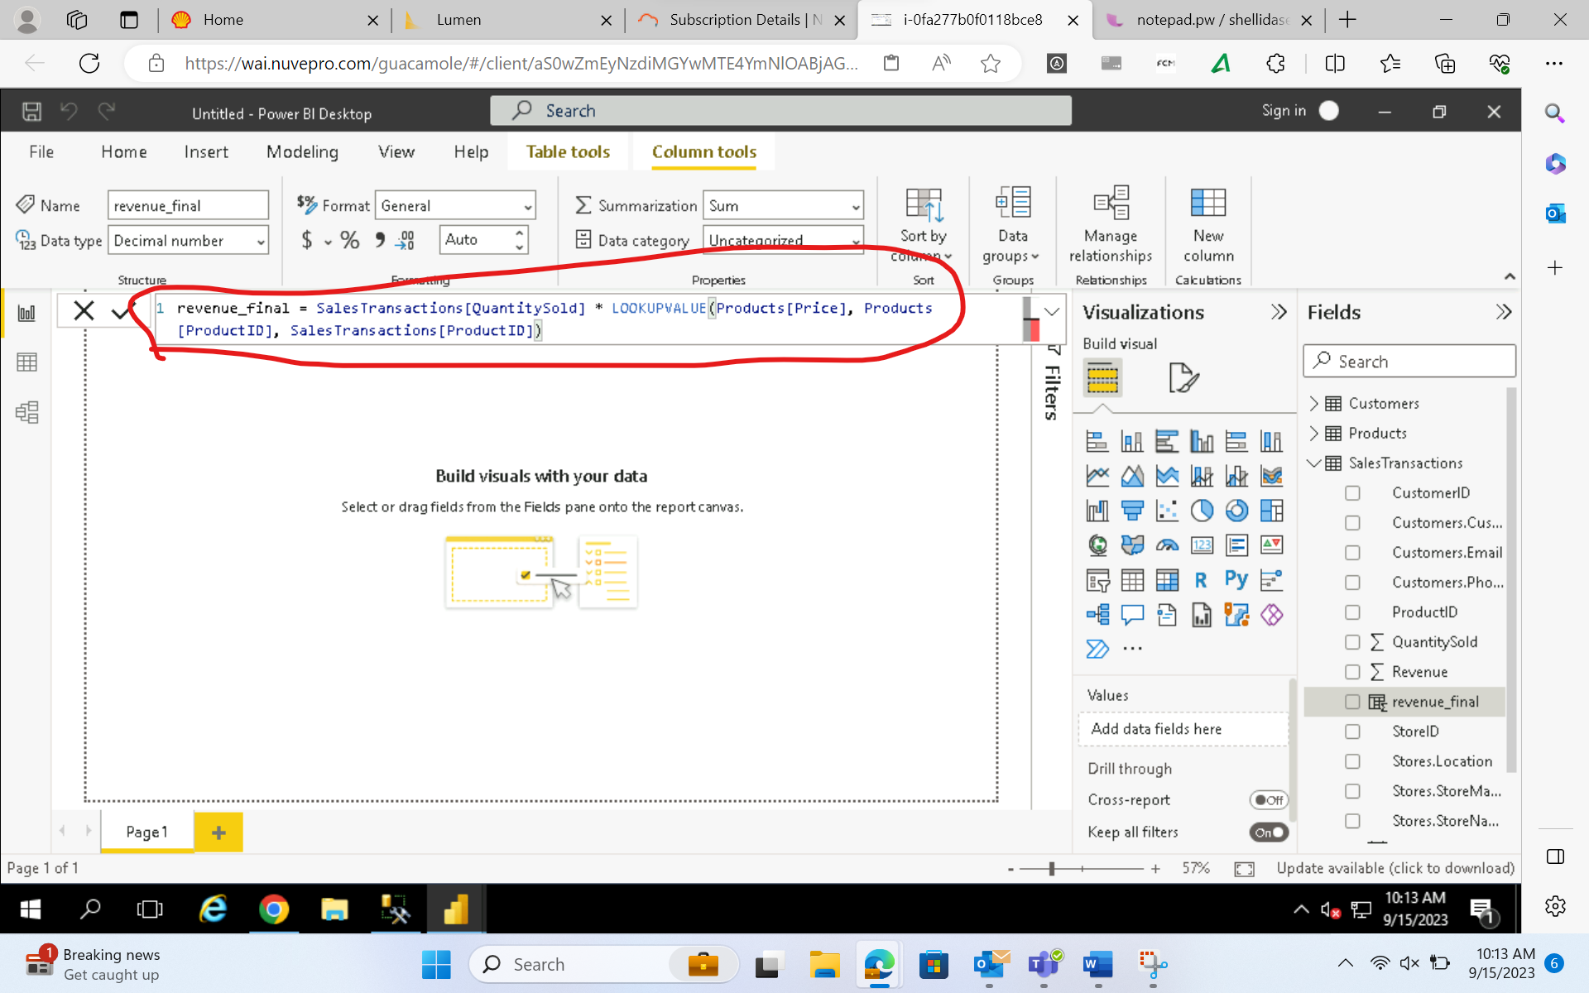

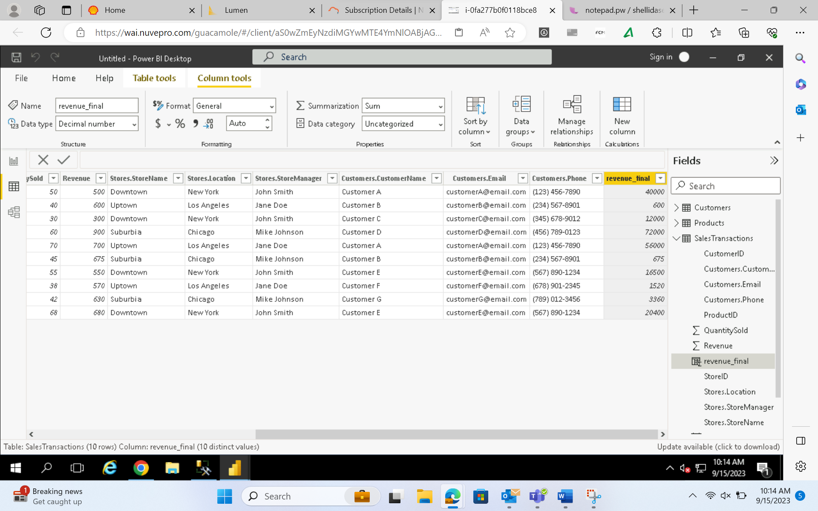

Requirement 3: Data Modelling –

• Create Relationships:

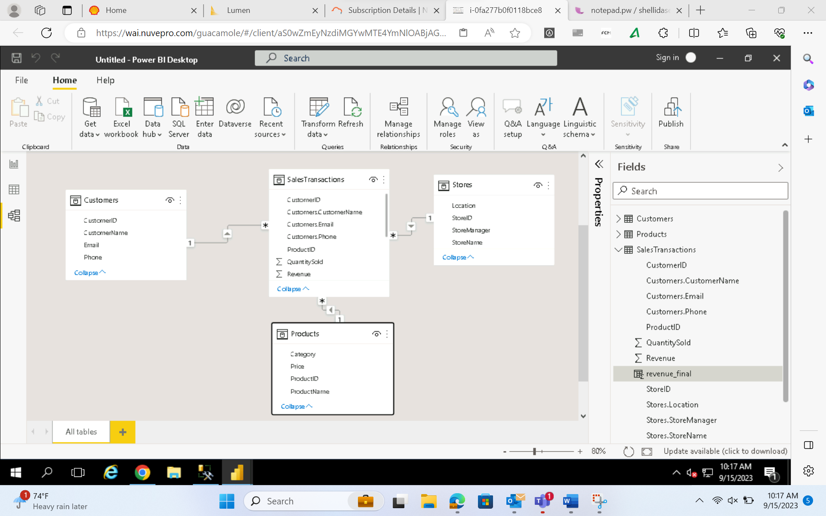

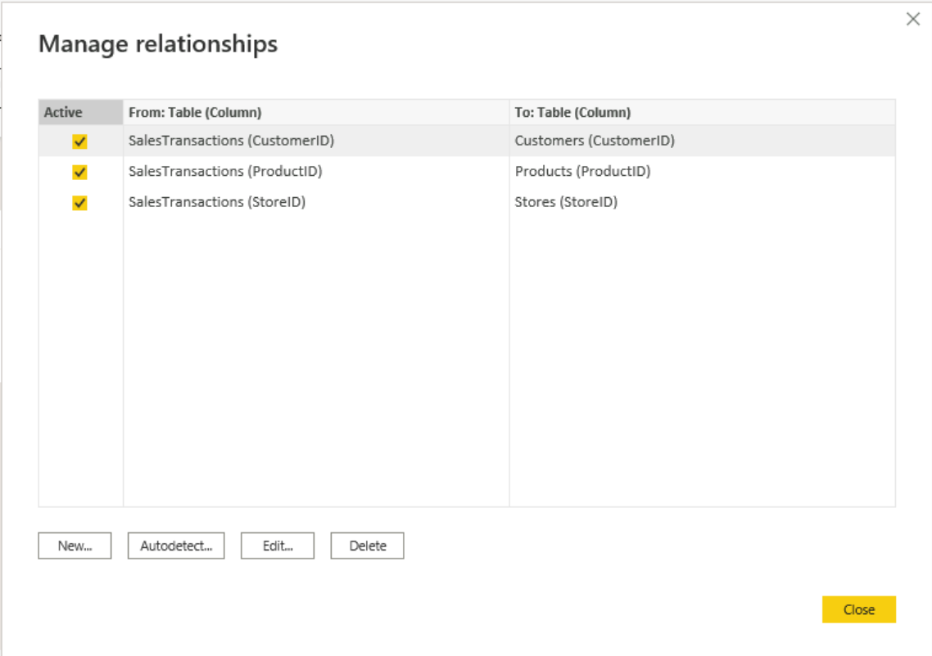

• Create Hierarchies:

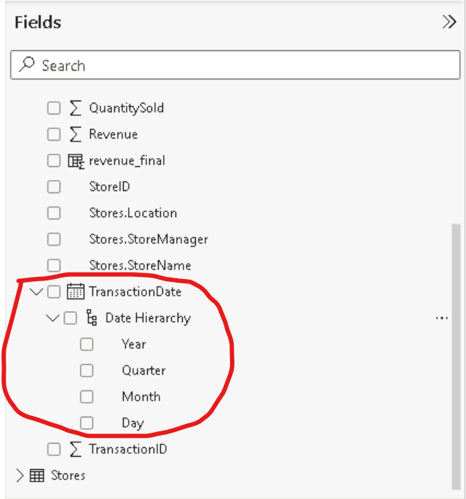

Requirement 4: Business Queries and Analysis –

1. Who are the top-spending customers based on their total purchase amount?

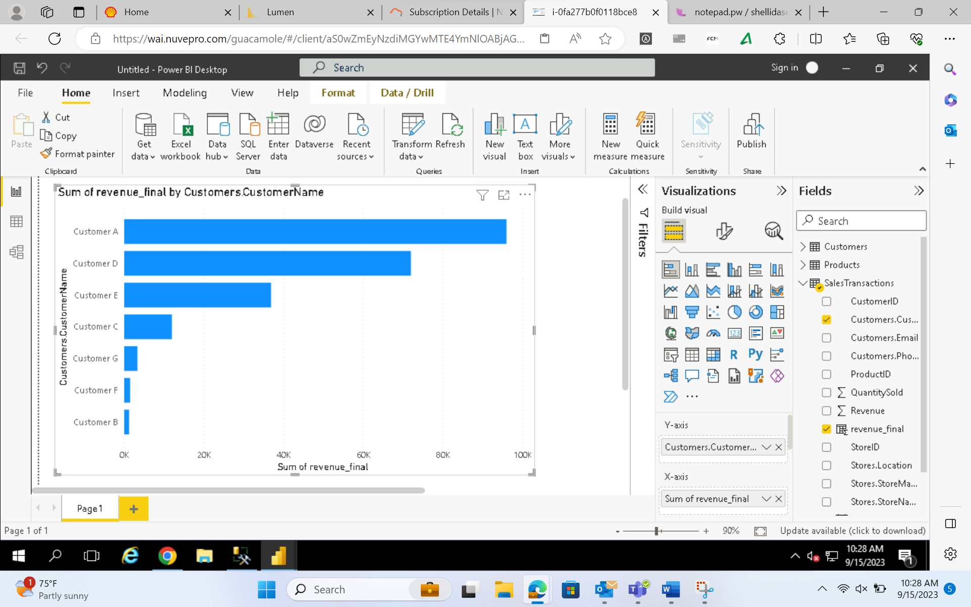

2. How is sales revenue distributed among different store managers?

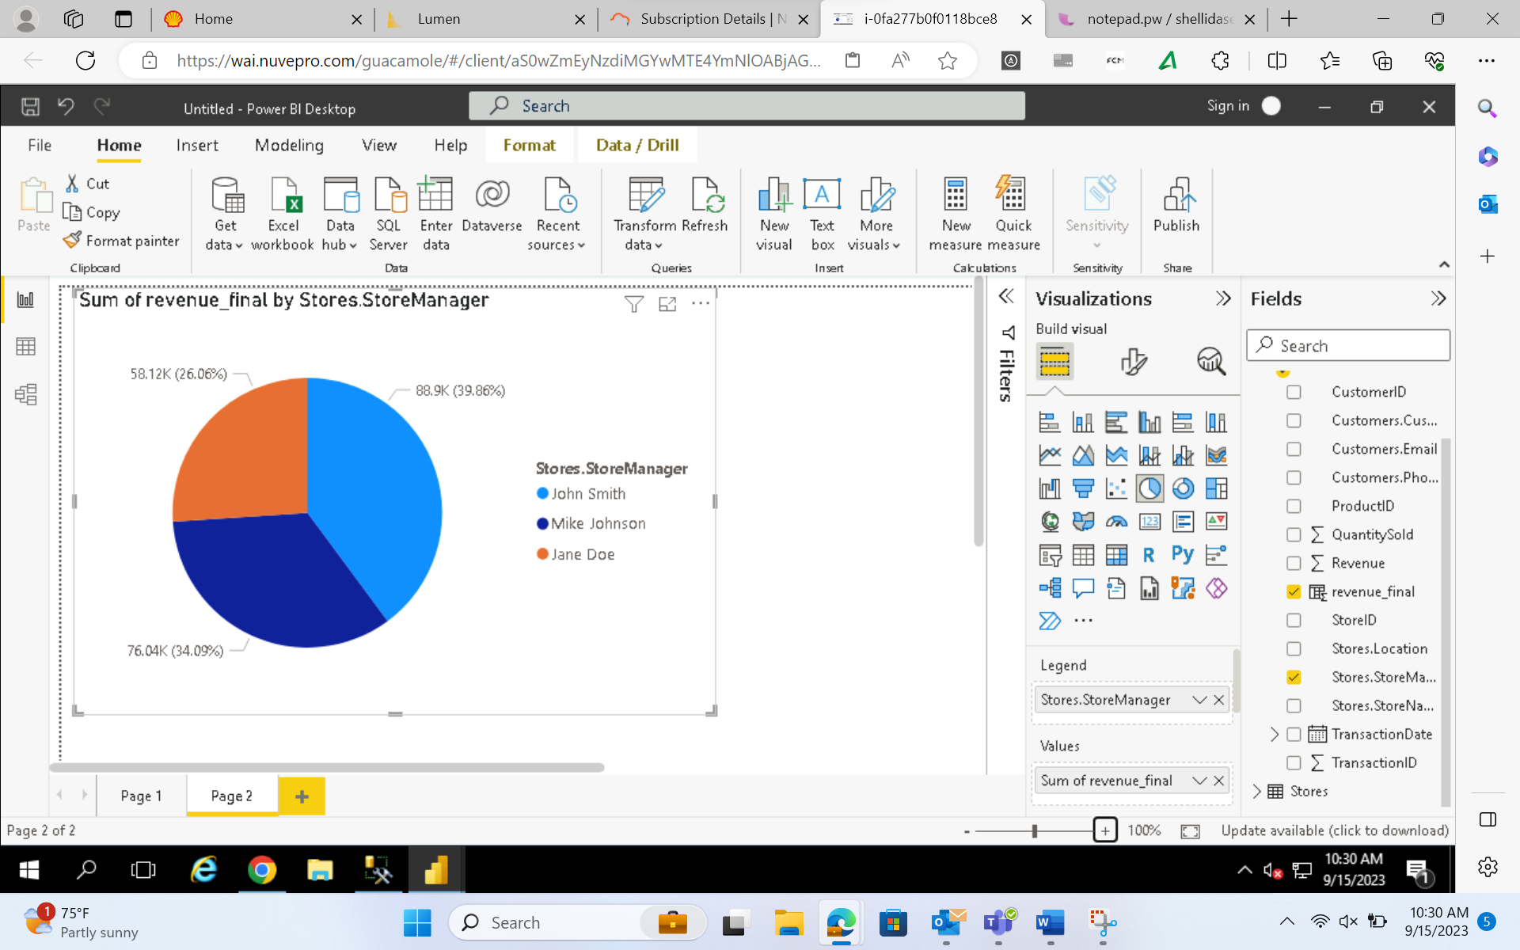

3. What is the average price of products in each category?

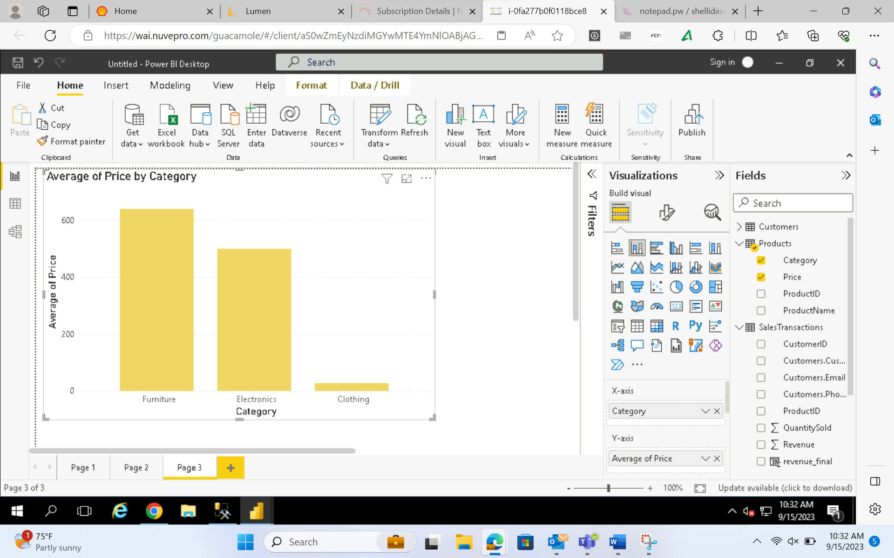

4. Are there specific days of the week when sales are higher?

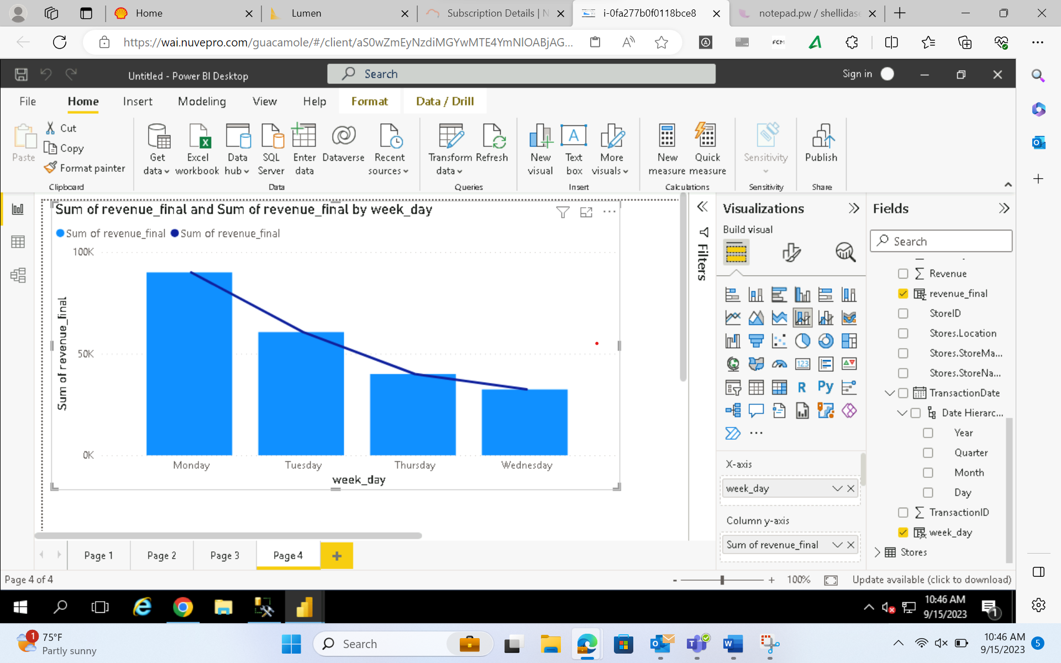

According to above visualization Monday has highest revenue

5. How do sales trends vary by product category on a monthly basis?

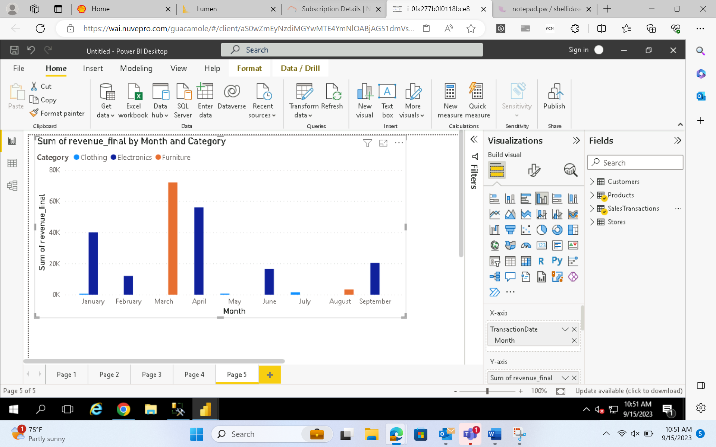

6. What percentage of products account for 80% of total sales revenue?

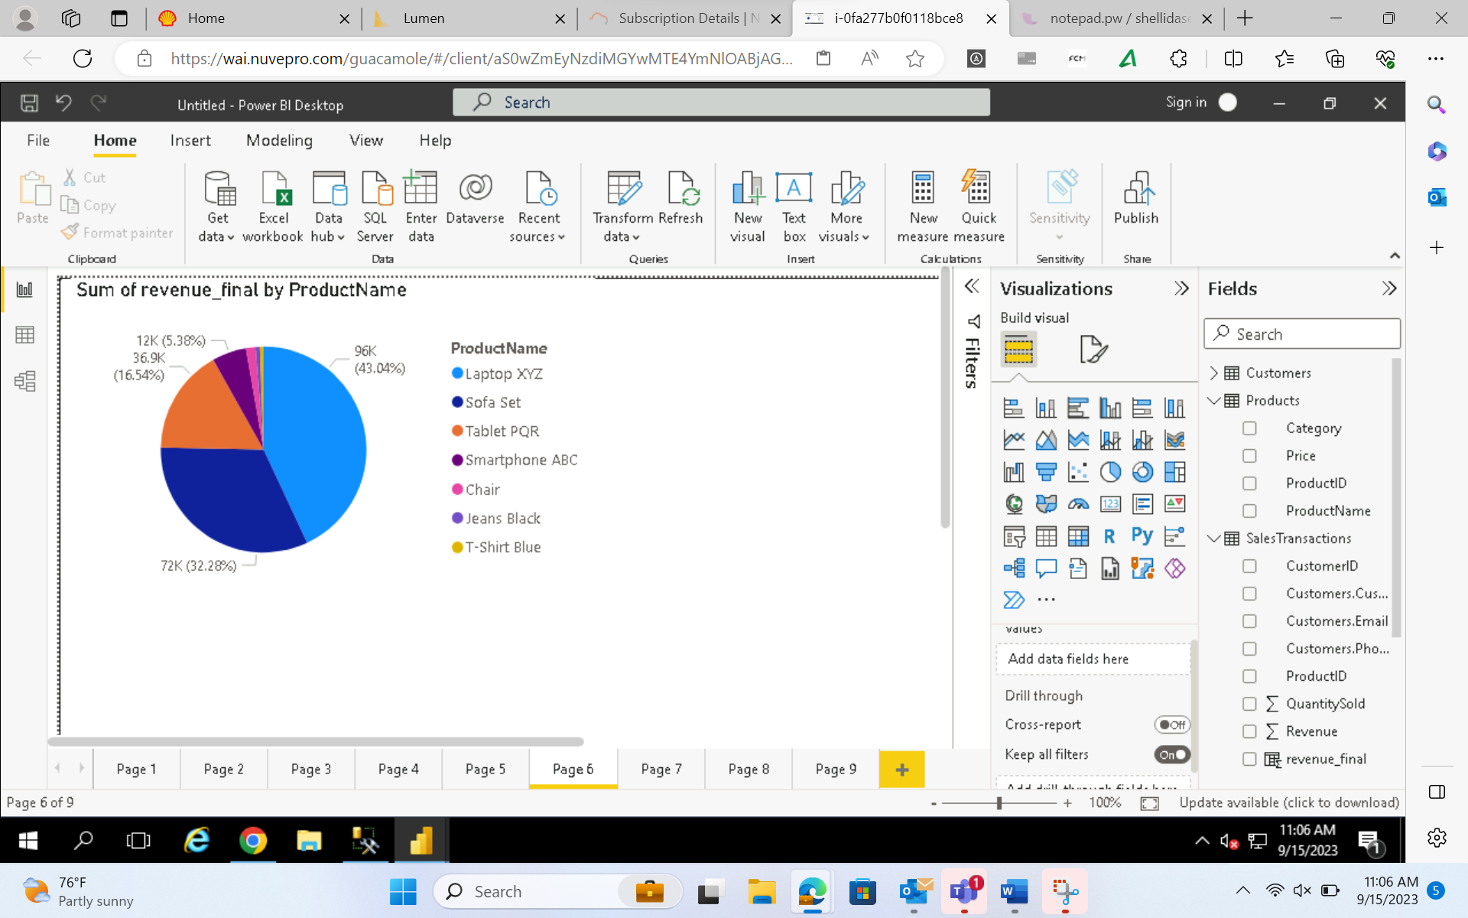

ACCORDING TO THIS LAPTOP XYZ and SOfA SET ACCOUNT FOR 80%

7. Are there any trends in repeat customer purchases?

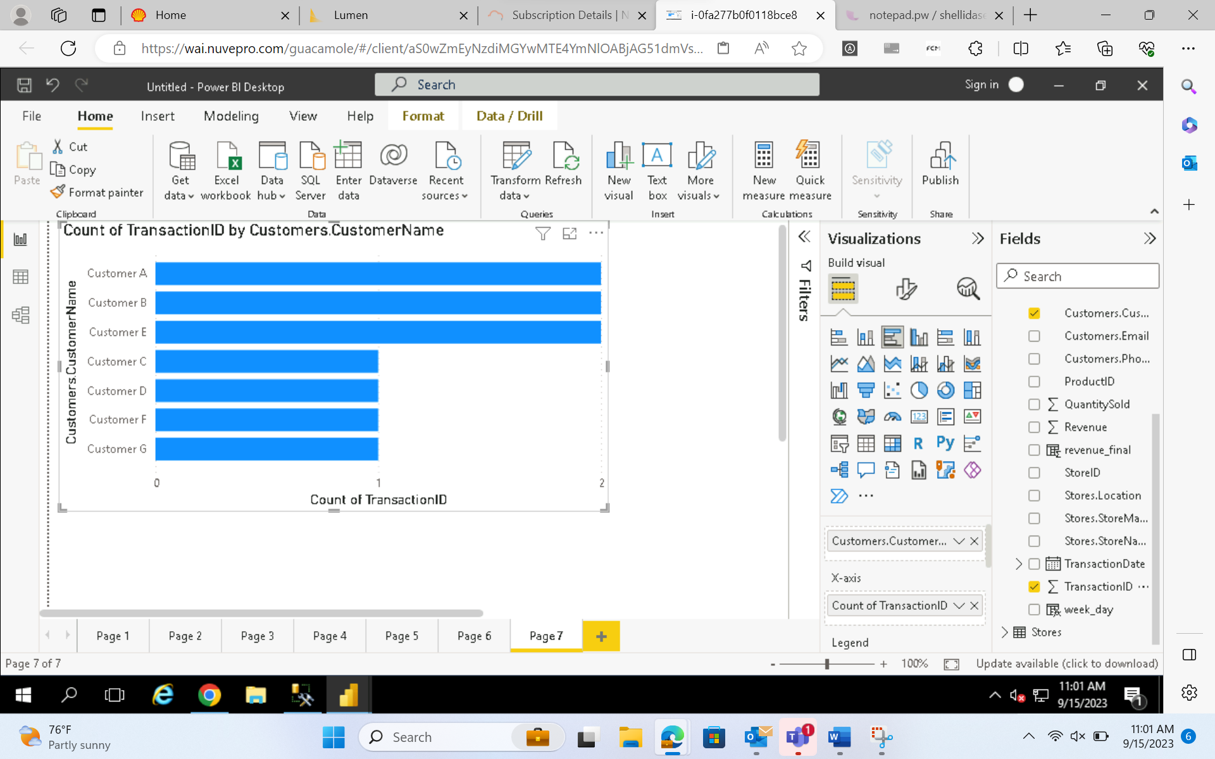

8. Which product categories perform best at each store location?

For Chicago -

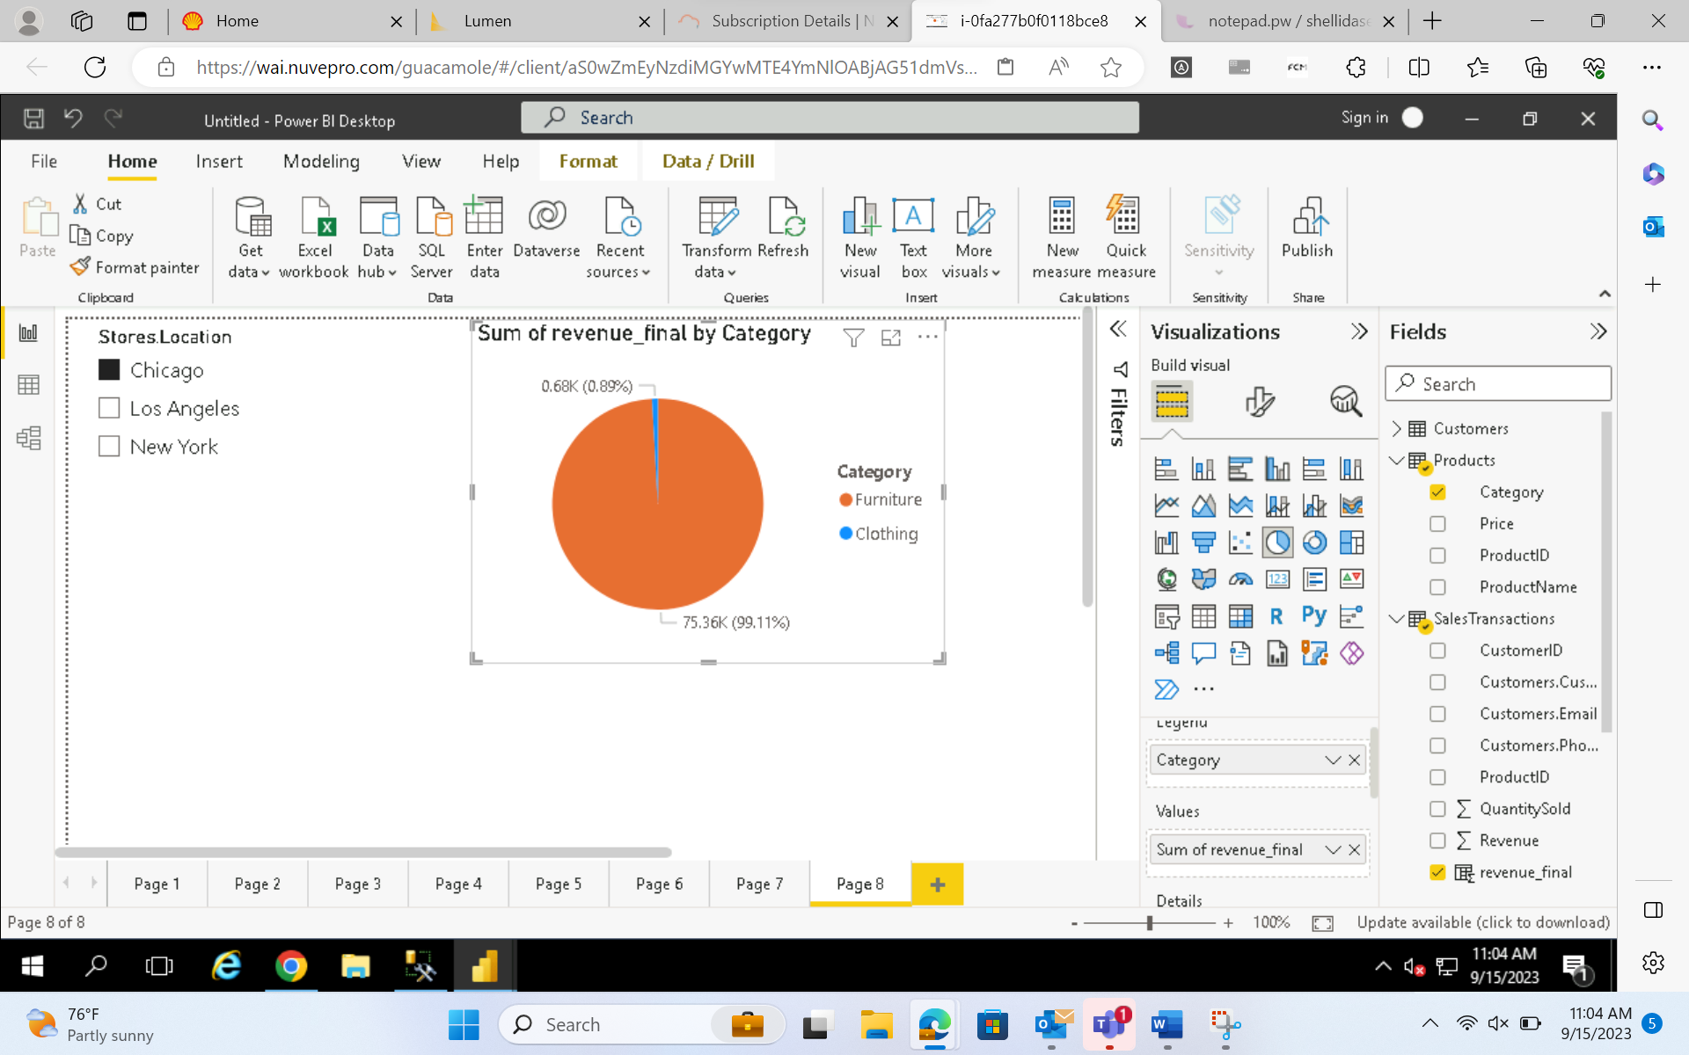

For Los Angeles –

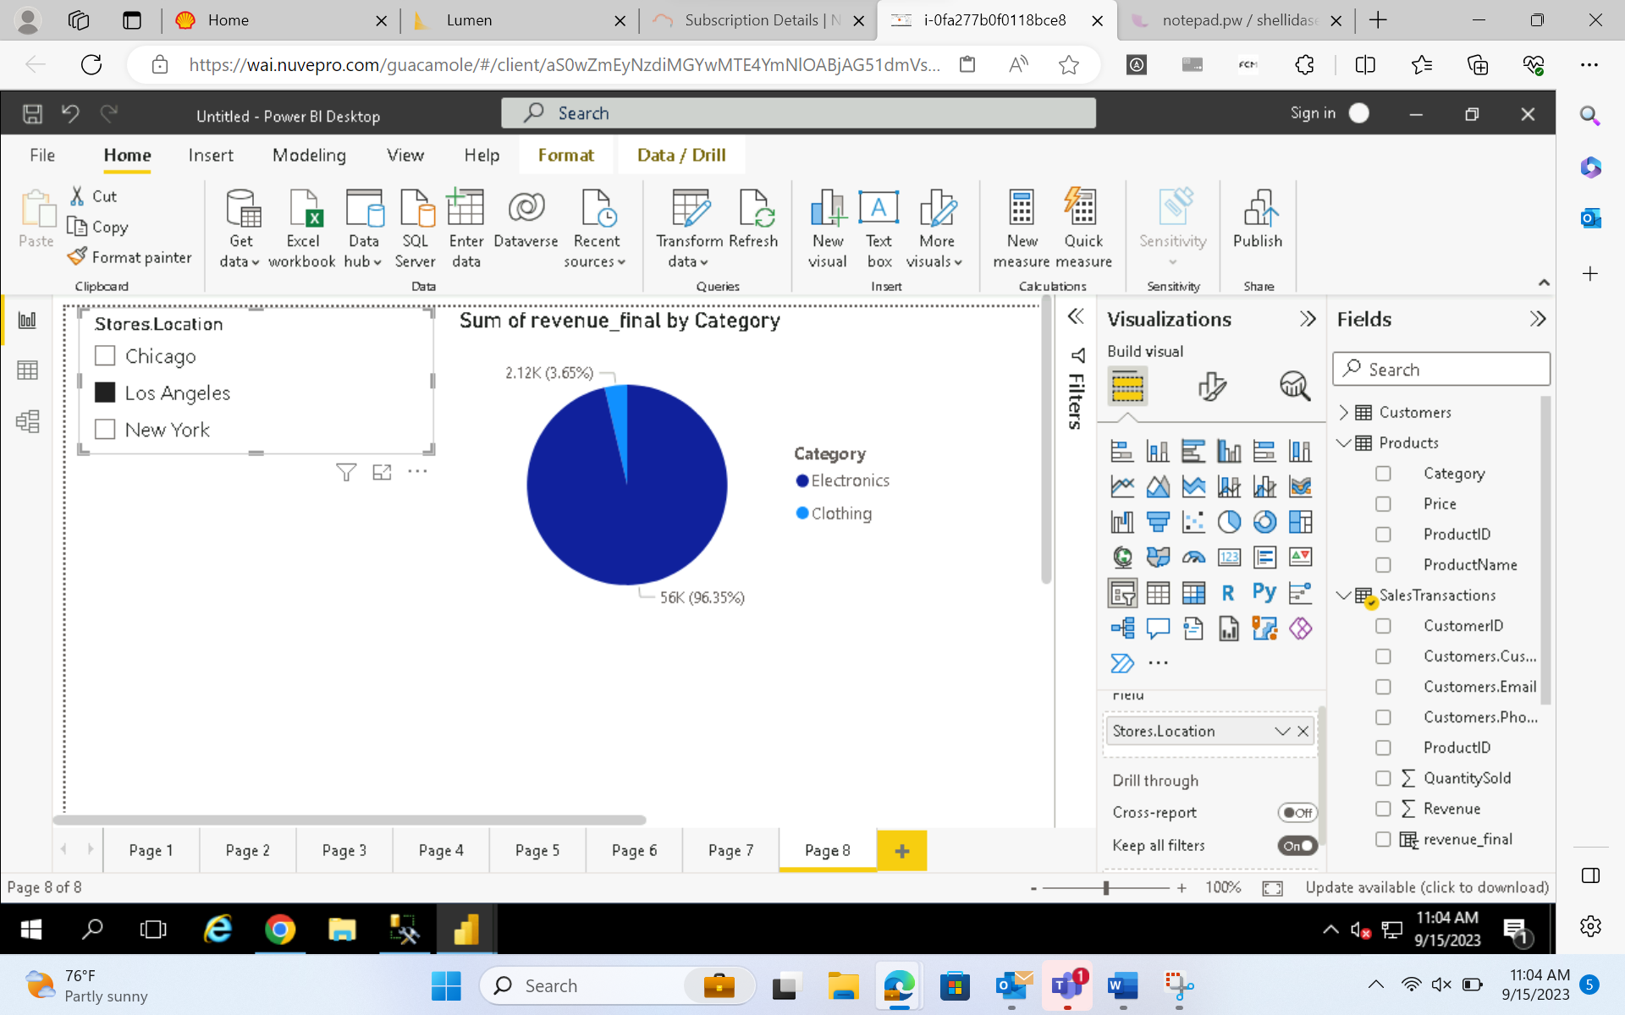

For NewYork –

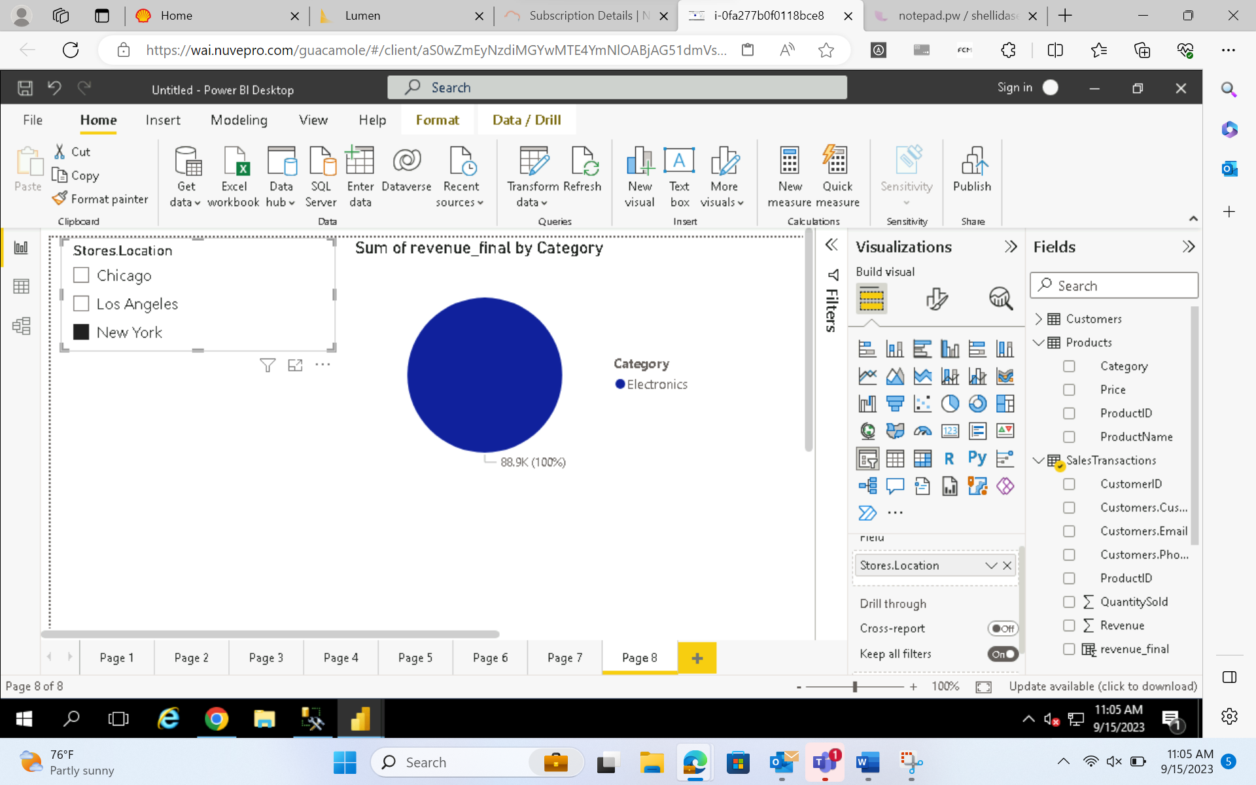

Overall –

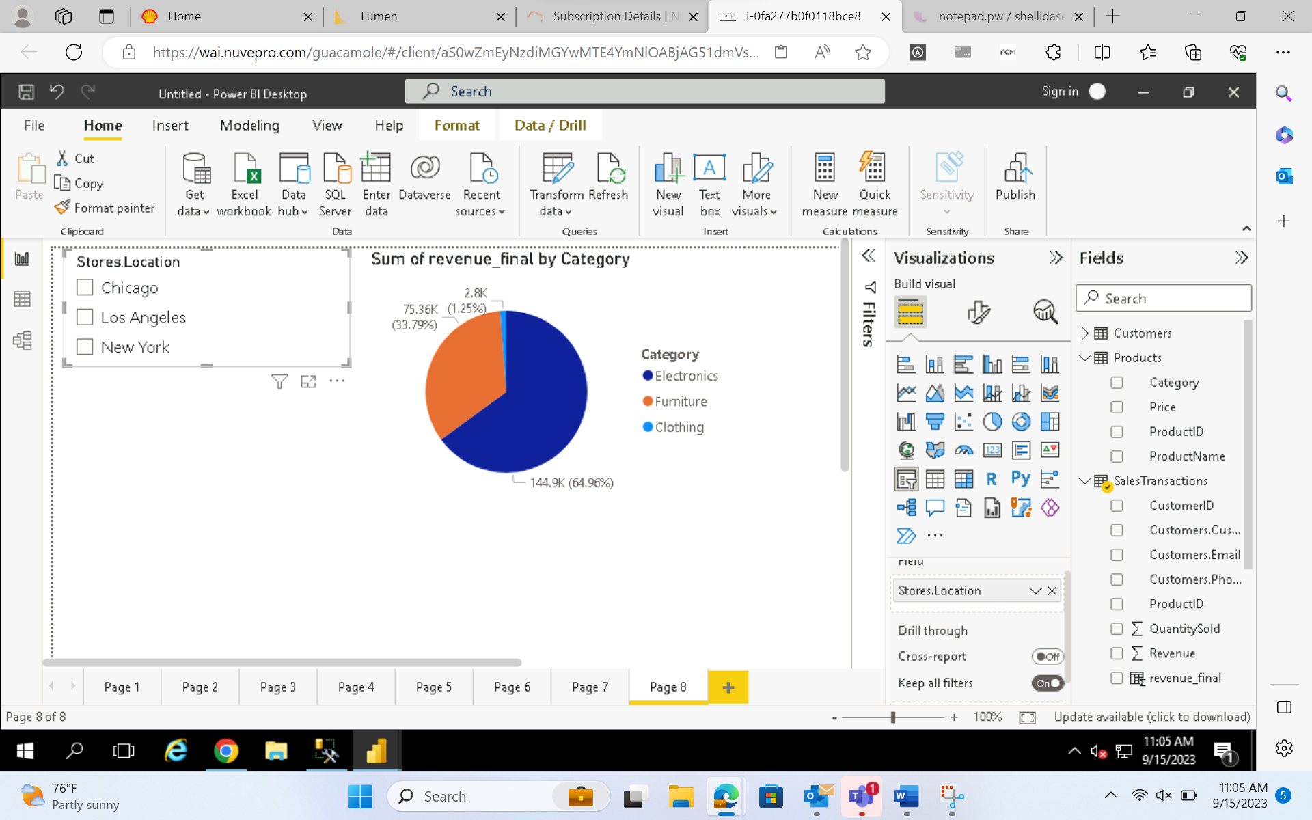

9. Are there any seasonal patterns or trends in sales for specific products or categories?

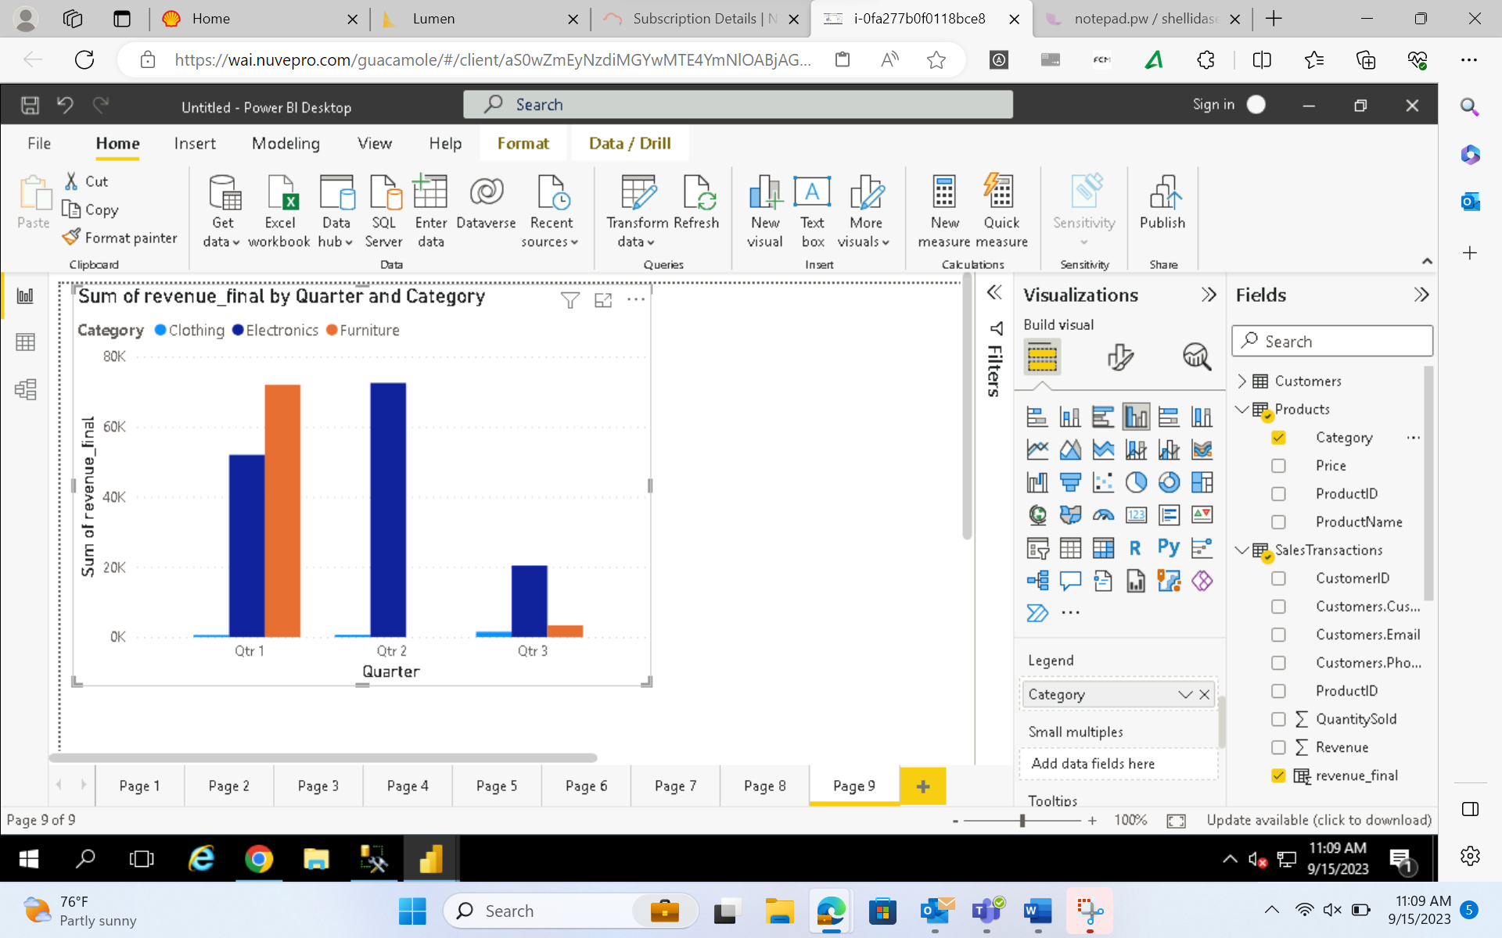

**According to above diagram FURNITURE was sold most in the 1st quarter season. 3rd Quarter season had least sales in all categories.**

10. Can customers be segmented into high, medium, and low-value segments based on their purchase history.

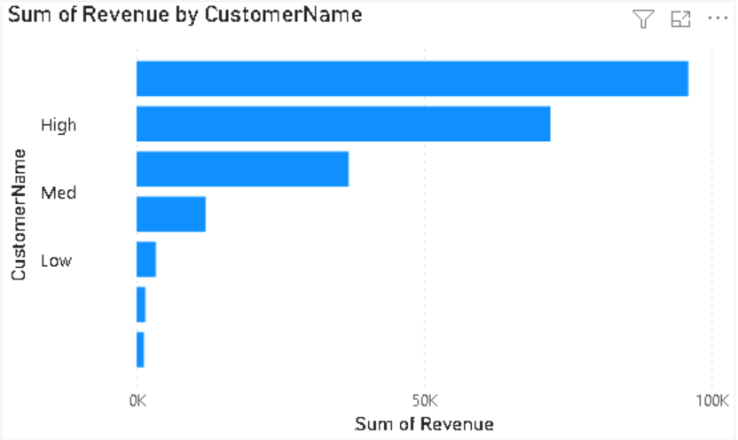

**Requirement 5: Data Insights and Recommenda7ons** –

**Analysing Patterns:**

Regional Variations: Los Angeles and New York show high demand for electronics.

Chicago has a greater amount of Furniture sales

Seasonality**:**

Quarter 1 has the highest sales and sold most amount of sofa sets.

Quarter 2 has the next highest amount of sales and got most revenue from Laptop XYZ

Quarter 3 had least sales and had the most revenue generated by Tablet PQR

**Generate Insights:**

Stock more electronics in Los angeles and New York.

Stock more furniture in Chicago.  
Increased sales in the weekdays Monday and Tuesday compared to other days

**Creating stories and dashboards for insights**

The above conclusions are based on the screenshots attached.